Virgin and artificially aged microplastics as a vector for a mixture of pharmaceuticals

Presenting author: Diana S. Moura¹

Pestana, Carlos J.¹, Moffat, Colin F.¹, Gkoulemani, Nikoletta², Hui, Jianing², Irvine, John T. S.² and Lawton, Linda A.¹
¹School of Pharmacy and Life Sciences, Robert Gordon University, Aberdeen
²School of Chemistry, University of St Andrews, North Haugh, St Andrews

Theme: Environmental Processes in Soil, Water and Air/Emerging Contaminants

Water quality is of increasing global environmental concern. An indicator of poor water quality is the presence of pharmaceuticals, persistent organic pollutants, and heavy metals. Other pollutants such as microplastics (< 5 mm), are now commonly detected in aquatic systems. There is an emerging concern that microplastics can act as a vector for chemical micropollutants when they co-exist in the same environment, including pharmaceuticals. This study evaluated a mixture of five pharmaceuticals (16 µmol L⁻¹ each) with six microplastic types (2 g L⁻¹) with median (D₅₀) particle sizes of 20 ± 13 µm (small) and 122 ± 24 µm (large). Additionally, the microplastics were artificially aged to evaluate the impact of microplastics aging on adsorption of the pharmaceuticals.
The two sizes of virgin and aged polypropylene (PP), polyethylene terephthalate (PET), polystyrene (PS), polyamide (PA), polyethylene (PE), and polyvinyl chloride (PVC) were placed in contact with a mixture of ibuprofen, carbamazepine, fluoxetine, venlafaxine, and ofloxacin for 48 hours. The size of the particles, the microplastics aging, the type of microplastics, and the compound hydrophobicity were key factors affecting the adsorption of pharmaceuticals onto microplastics. Virgin and aged small PP adsorbed all the pharmaceuticals in the mixture. Fluoxetine, the most hydrophobic pharmaceutical investigated, exhibited ~60% adsorption on small and large virgin PA and ~70% adsorption on virgin small PVC. Aging the microplastics increased the adsorption by the microplastics. Fluoxetine adsorbed onto all aged microplastics showing between ~18% (PET) and 100% (PP, Figure 1) adsorption.
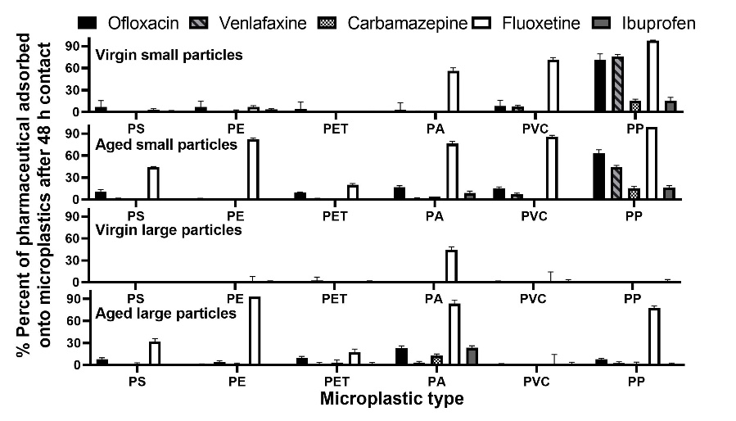
Figure 1: Percent adsorption of ofloxacin, venlafaxine, carbamazepine, fluoxetine, and ibuprofen onto virgin and aged polystyrene (PS), polyethylene (PE), polyethylene terephthalate (PET), polyamide (PA), polyvinyl chloride (PVC), and polypropylene (PP). The microplastics were classified as small (D₅₀ = 20 ± 13) and large (D₅₀ = 122 ± 24 µm).
The current investigation highlights the potential of the microplastics to act as a vector for pharmaceuticals in the aquatic environment. The high ecotoxicity of fluoxetine and the considerable adsorption potential of small, aged microplastics is of concern, especially when considering the possible implications should they enter the food chain.

